Client Business Requirements
Program / Project Name MISYS-37: Invoice Trade Report

Program / Project No.: 0471
Document Version: 1.001 (2016-03-2406-23)
Template Version: 1.00 (2013-02-28)
Prepared by: Clare Scully
Group: Client Change
Function: Client Service & Solutions
RBC Investor & Treasury Services™ is a global brand name and is part of Royal Bank of Canada. RBC Investor & Treasury Services is a specialist provider of asset servicing, custody, payments and treasury services for financial and other institutional investors worldwide. RBC Investor Services™ operates through two primary operating companies, RBC Investor Services Trust and RBC Investor Services Bank S.A., and their branches and affiliates.
In the UK, RBC Investor Services Trust operates through a branch authorized by the Prudential Regulation Authority and regulated by the Financial Conduct Authority and the Prudential Regulation Authority. The Dubai Branch of RBC Investor Services Trust is regulated by the Dubai Financial Services Authority.
In Australia, RBC Investor Services Trust is authorized to carry on financial services business by the Australian Securities and Investments Commission under the AFSL (Australian Financial Services Licence) number 295018.
In Singapore, RBC Investor Services Trust Singapore Limited (RISTS) is licensed by the Monetary Authority of Singapore (MAS) as a Licensed Trust Company under the Trust Companies Act and was approved by the MAS to act as a trustee of collective investment schemes authorized under S 286 of the Securities and Futures Act (SFA). RISTS is also a Capital Markets Services Licence Holder issued by the MAS under the SFA in connection with its activities of acting as a custodian.
In Hong Kong, RBC Investor Services Bank S.A. is a restricted license bank and is authorized to carry on certain banking business in Hong Kong by the Hong Kong Monetary Authority. RBC Investor Services Trust Hong Kong Limited is regulated by the Mandatory Provident Fund Schemes Authority as an approved trustee.
® / ™ Trademarks of Royal Bank of Canada. Used under licence.

Revision List
Ver. # | Date | Author | Description | Distribution
0.01 | 03/03/2016 | Clare Scully | Initial draft to kick off documentation process | Internal
0.02 | 21/03/2016 | Clare Scully | Updated following review with Fiona Ryan | Internal
1.00 | 24/03/2016 | Clare Scully | No changes from 0.12, version noted as “distributed” version to Mediolanum | All stakeholders
1.01 | 23/06/2016 | Shane McMunn | Updated following feedback from Mediolanum | All Stakeholders

Table of Contents
The purpose of this document is to:
- Provide a vision for the expected outcome of the project.
- Act as a form of agreement, outlining project particulars and deliverables.
- Note: Requirements do not necessarily have to be collected and presented in this artefact format. If requirements software tools or alternate formats such as use cases are being used, then printed output of these formats can be substituted here.
Revision List 2
Table of Contents 1
1. Executive Summary 2
1.1. Project Identification 2
1.2. Related Documents 2
2. Project Description 3
2.1. Purpose 3
2.2. Critical Success Factors 3
2.3. Processes Impacted 3
2.4. Business Requirements Scope 3
3. Assumptions, Dependencies & Constraints 5
3.1. Assumptions 5
3.2. Dependencies 5
3.3. Constraints 5
3.4. Process Flows 6
3.5. Requirements 7
3.5.1. Functional Requirements 7
3.5.2. Non – Functional Requirements 11
4. Sign off Block 12
Reviewers 12
5. Appendix 1 – Modified Sample Report 13
6. Appendix 2 – Funds in Scope 13
7. Appendix 3 – Common Custody/Fund Accounting Fund Identifier 13
8. Appendix 4 – Fee Code Field on Focus Screen 14

- Executive Summary
  - Project Identification
Project Name | Mediolanum Enhancements 2016 | Project No. | 0471
Program Name | As above | Program No. | As above
Project Start Date | 2016 | Project End Date | 2016
Project Manager | N/A | Group & Function | N/A
Program Manager | Kate Cullen | Group & Function | Associate Director, Client Change
Sponsor | Renato Moreschi | Group & Function | MD, Client Operations
  - Related Documents
Document Name / Description | Author | Purpose / Comments
Sample “to be” report | Clare Scully | Sample format and content of report to be used for the purposes of the reconciliation
Funds in Scope | RBC | List of umbrella codes
Common Fund Accounting & Custody Fund Identifier | RBC | List of all codes (concatenation of MF Code + Fund Manager ZCode)
Fee Code Field on Focus Screen | RBC | For Business SME – detail on how invoice fee will be captured on Custody system

- Project Description
  - Purpose
- Mediolanum Dublin will start to use new systems late 2016 which will result in a change to the way in which they communicate with RBC.
- These systems are FusionInvest (Portfolio & Risk Management) and Intellimatch (Reconciliation system).
- Mediolanum have requested various information from RBC that will feed both systems:

Flow: RBC -> Mediolanum (High Level)
FusionInvest | Intellimatch
Custody & Fund Accounting trade file for Delegate Manager trades | Custody & Fund Accounting trade files for MAML trades
GFP confirmation of trading | Custody & Fund Accounting trade file for Delegate Manager trades
FX forwards initiated by RBC (e.g. COS) | Custody positions for all asset types (MAML and Delegate Managers)
Corporate Actions for MAML and Delegate Managers | Valuation for all security positions held on the portfolio (MAML and Delegate Managers)
Custody invoice file for MAML and Delegate Managers | Settled Cash and cash movement report (MAML and Delegate Managers)
 | GFP confirmation of MAML trading
 | Income (dividends) for MAML funds
 | Corporate Actions for MAML and Delegate Managers
 | Custody invoice file for MAML and Delegate Managers

- The purpose of this document is to provide the requirements for the category: Custody invoice file for MAML and Delegate Managers.
  - Critical Success Factors
- Successful loading of invoice information to Fusion/Intellimatch.
  - Processes Impacted
Process | Impact  (New/Deleted/Modified)
New report issued to Mediolanum on a daily basis | New
Capturing of a specific code (fee type identifier) by Transaction Management when booking Mediolanum/Gamax Invoices | New
  - Business Requirements Scope
Business Requirements Scope
Creation of new report to capture invoice payments on booking date daily at close of business at approx 2/3 am on T+1 on the Custody system.
Creation of new ‘fee types’ in the Custody system, and limiting of drop down ‘fee type’ menu to the 6 different types that will be used for Mediolanum.

Scope Inclusions
- All PTGs (Dublin and Luxembourg)
- Both MAML and Delegate Manager PTGs
- New process to capture invoice type when booking invoices to Custody system Focus.
- New fee types available to users when booking invoices to Focus, and only the 6 types that will be used for Mediolanum business available to Focus users when booking an invoice on a Mediolanum fund.
- New extraction from RBC’s Custody data warehouse (Infocentre)
- Report should only includes all invoice payments.
- Report will be sent to Mediolanum daily, via SFTP. Mediolanum have requested RBC push to Mediolanum’s server.
Scope Exclusions
- Any requirement to send the report at any time other than overnight (circa 2/3am after the GLOBAL1 flow/dump from RBC’s custody system Focus).
- Amending the CPJ report to meet the report requirement. This was originally discussed but discounted by RBC IT as approach was more complex than creating a new report.

- Assumptions, Dependencies & Constraints
  - Assumptions
Description of Assumption & Context | Impact if Not True | Recommended Action /  Resolution / Comments
Mediolanum/Cronos do not have a specific filename convention that they need RBC to confirm to when creating the new files | Requirements set out in this document may not be fully correct | Mediolanum/Cronos to formally confirm requirement
Mediolanum/Cronos do not require a split between Dublin and Luxembourg data, and there is no business reason to provide different files | Requirements set out in this document may not be fully correct | Mediolanum/Cronos to formally confirm requirement
Mediolanum/Cronos only require invoice detail to the level requested in CR2. They do not require RBC to include the comments keyed in by the Focus user when booking the deal into the report | Requirements set out in this document may not be fully correct | Mediolanum/Cronos to formally confirm requirement
  - Dependencies
Description of Dependency | Impact if Not in Place | Recommended Actions /  Resolution / Comments
Resource – Mediolanum/Cronos to review docs and be available for UAT and queries | Delivery timeframe requested by Mediolanum may not be met | Full project plan to be agreed separately between all parties
Mediolanum agreeing on common Custody and Fund Accounting identifier which as at the time of writing is still outstanding due to potential to bulk all hedging PTGs together | N/A – this is marked as a dependency as it generally impacts the project, but no invoice deals will ever be booked on the hedging PTGs | Mediolanum/Cronos to provide final requirements around common fund identifier  Update 24/03: Mediolanum confirmed RBC can proceed on basis that no bulking will be required – a code per PTG can be reported
Set up of functionality for RBC to push file to Mediolanum’s SFTP site, This is being progressed as a separate item with Mediolanum and is not in place at the time of writing of this document. | N/A | Details of SFTP to be shared closer to delivery date
  - Constraints
Description of Constraint | Impact if Not in Place | Recommended Actions /  Resolution / Comments
Technical constraints may be identified as part of the IT detailed analysis | All requirements may not be able to be delivered | Results of detailed analysis to be shared with all stakeholders once available

  - Process Flows
High level ‘to be’ flows are outlined below. Mediolanum system information has been included for illustrative purposes.
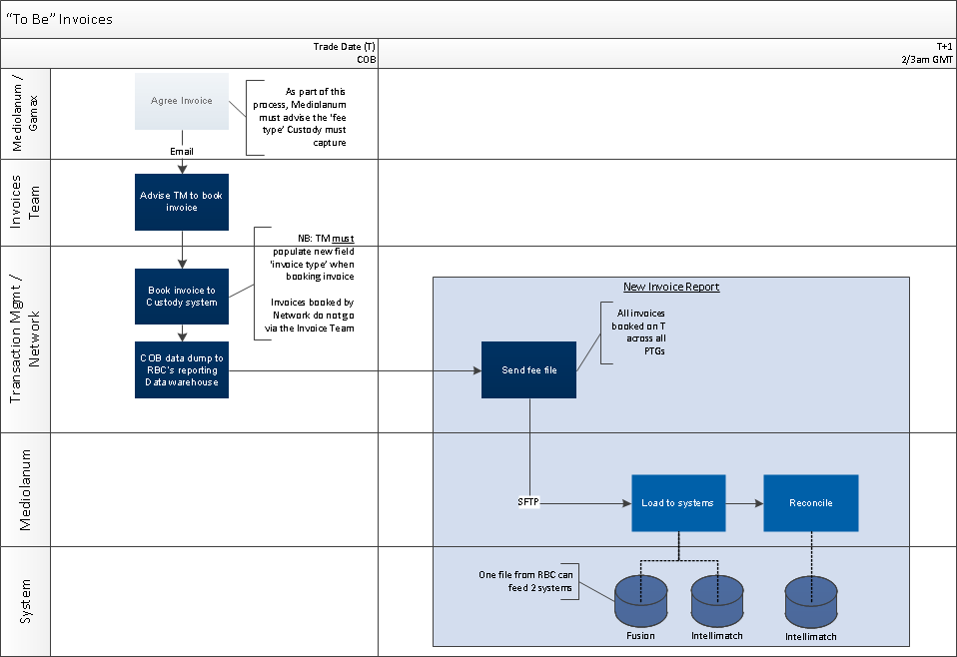
  - Requirements
    - Functional Requirements
General Requirements
Client Requirements
Product, Features & Options
Marketing & Sales
Communications
Credit & Risk
Other

ID | Requirement | Priority  1=high  5=low | Stability  High  Med  Low | Origin | Benefit
CR1 | File sent on a daily basis that captures invoices booked to the funds | 1 | High | Mediolanum | To load invoices to Fusion & Intellimatch.
CR2 | Capturing of an invoice type in the Custody system when booking invoices as below. | 1 | High | Mediolanum | Requirement for audit and management reporting
  Type | Invoices Captured
  Management Fees | Management fee, Cash Management fee, Investment Management fee
  Performance Fees | Performance fee
  RBCI&TS Fees | Admin fee, Transfer Agency fee, Trustee fee, Custodian fee
  Account Opening  Fee | Sub-custodian/market account opening fees debited directly from a fund
  Account Maintenance  Fee | Sub-custodian/market account maintenance fees debited directly from a fund
  Other / 3rd Party  fees | Risk & Research fee, Legal & Audit fee, Expenses 124, Establishment expenses. Any other invoice payment

Operational Requirements
Operational Requirements
ID | Requirement | Priority  1=high  5=low | Stability  High  Med  Low | Origin | Benefit
OPR1 | Mediolanum to advise fee type to be captured when booking the invoice as part of the communication with the Invoice team.  This is a new process that must be agreed with Mediolanum and documented in the RBC procedures | 1 | High | Ops | To meet client requirement
OPR2 | Create a new extraction capturing the requirements set out in OPR2-OPR9.  A description of all fields in the report is provided in table 1.1. A sample ‘to be’ report is in Appendix 1. | 1 | High | Ops | To meet client requirement
OPR3 | Report must be in CSV format.  Delimiter must be semi-colon. | 1 | High | Ops | To meet client requirement
OPR4 | Report must be sent to Mediolanum by FTP. Details to be confirmed at a later date.  (Mediolanum require RBC to push to their site, but this is being discussed separately). | 1 | High | Ops | To meet client requirement
OPR5 | Report must be sent daily at close of business | 1 | High | Ops | To meet client requirement
OPR6 | Report must pick up all Mediolanum PTGs across the Best Brands, Challenge, Portfolio, Specialities SIF and Gamax fund ranges.  Report must be parametrised on umbrella code and not PTG.  Please refer to Appendix 2 for more information on funds. | 1 | High | Ops | To meet client requirement
OPR7 | Report sent COB on T must capture all invoices either booked (status 30) or cancelled (i.e. trades that move to Focus status 56 on T must be captured) on the Custody system Focus on T.  The report must pick up the RBC invoice transaction types FA (invoice impacting 1 PTG) and FM (invoice impacting multiple PTGs | 1 | High | Ops | To meet client requirement
OPR8 | TM must capture the invoice type per Mediolanum’s requirement CR2. This will require a new business process. Please refer to Appendix 4 for more detail on how this will be captured in the Custody system Focus.  It will also require the creation of 2 new subcategory invoice type identifiers on Focus (the codes stored in table L408). The 2 new types should be:  - RBC I&TS Fees  - Other Fees | 1 | High | Ops | To meet client requirement
OPR9 | There is currently a wide list of invoice types available in the field where the fee type will be captured. The list should be limited to the below fee types when a booking is being made on a Mediolanum fund (PTR) or PTG.  - COGES  - COPER  - FRACM  - FRACO  - 2 NEW TYPES REQUESTED IN OPR8  NB: Not all invoices are booked by TM, some are instructed by Network. | 1 | High | Ops | To meet client requirement
Table 1.1 Field description
ID | Field Name | Field Description | Format
1 | Fund Custody Code | PTG code | Alpha Numeric
2 | External Fund Identifier | Concatenation of Multifonds code and Fund Manager Actor ID. E.g. DB8815Z8997924 indicating PTG 628.  Where no Multifonds code exists in Focus, the PTG is used for holding collateral received from a third party that is not “owned” by the fund or included in the NAV calculation. In this situation a concatenation of the 1st 6 characters of the DFS Code + the Fund Manager Actor ID must be used.  For full list refer to Appendix 3 | Alpha Numeric
3 | Fund Name | PTG name | Alpha Numeric
4 | Trade Date | Trade Date | YYYYMMDD
5 | Value Date | Value Date | YYYYMMDD
6 | Fee Type | Fee Type description/label | Alpha
7 | Currency | Invoice Currency | Alpha
8 | Fee Amount | Invoice amount at PTG level  If the item being reported is a reversal of an invoice, the figure must be proceeded by a minus sign. | Alpha Numeric
9 | Transaction ID | Focus Trade Reference | Alpha Numeric
10 | Reversal Flag | ‘Y’ if item being reported is a cancellation  ‘N’ if the item being reported is a new invoice | Alpha

Third Party Requirements
Third Party Requirements
Measurement Requirements
Measurement Requirements
    - Non – Functional Requirements
Non- Functional Requirements
Audit
Business Continuity
Data Retention
Documentation / Training
Fraud
Privacy
Volume Impact
Security
Availability
Hardware
Software
Reliability
Scalability
Performance
Interface
Infrastructure

- Sign off Block
Role | Name | Group & Function | Signature | Date
Project Manager | Noel Nolan | Mediolanum
Program Manager | Kate Cullen | RBC

Reviewers
Reviewers are acknowledging that they have reviewed the Business Requirements and are in agreement with the content.
Role | Name | Group & Function | Signature | Date
Mediolanum | Lizy di Vetta | Mediolanum
Mediolanum | John Burrows | Mediolanum
Cronos | Steve Lazouras | Cronos
Cronos | James Shillingford | Cronos
SME - Dublin | Fiona Ryan | Transaction Management
SME – Luxembourg | Cathie Sartini | Transaction Management
BSA | Delphine Tempesta | IT
IT PM | Sebastien Paulissen | IT

- Appendix 1 – Modified Sample Report
The sample is taken from prod but only includes Dublin PTGs as the BA does not have access to Lux data. The dates selected are not reflective of the situation required for the report, but multiple dates were used to capture examples of different invoice types.


- Appendix 2 – Funds in Scope
Best Brands: Z9141208
Challenge: Z9162210
Portfolio: Z8733397
Luxembourg: TBC

- Appendix 3 – Common Custody/Fund Accounting Fund Identifier


- Appendix 4 – Fee Code Field on Focus Screen
FA Invoice Type
Field: Code lib
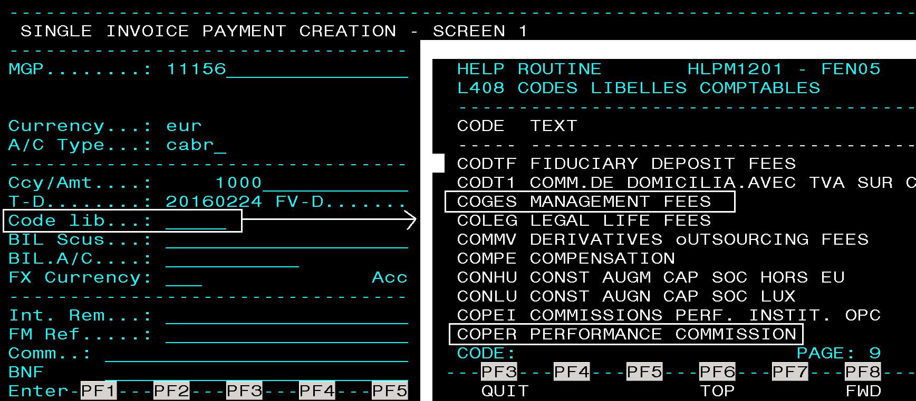

FM Invoice Type
Field: Desig. Code
